Assignment 3

Name: Ahmed Mahmoud Moustafa

No: 19100933

Q2:

Q3:

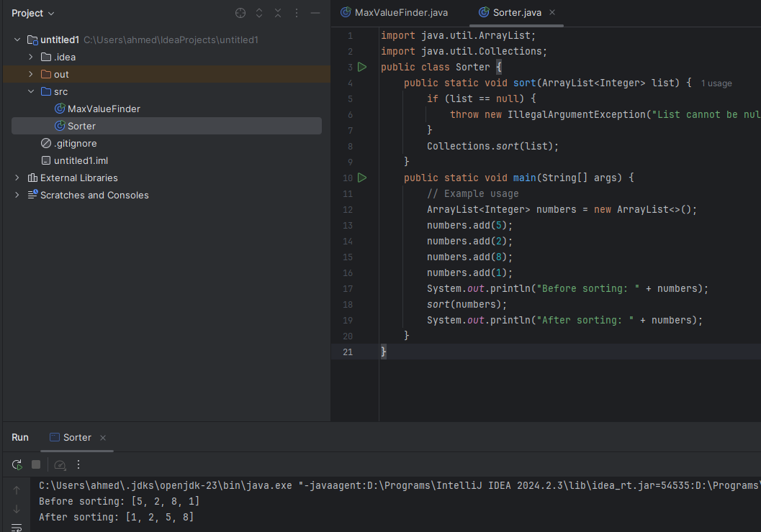

Q6:

